 Project for CSE471

Title of the Project:

Travel Planning and Tour Guide Finding Portal

Group Number:05 Group Members:

|  |  |
| --- | --- |
| Student ID | Student Name |
| 18201118 | Arko Mazhar |
| 19101116 | Sumaiya Mehjabeen |
| 18101575 | Tasnim Fuyara Chhoan |

Activity Diagram

LOGIN SYSTEM

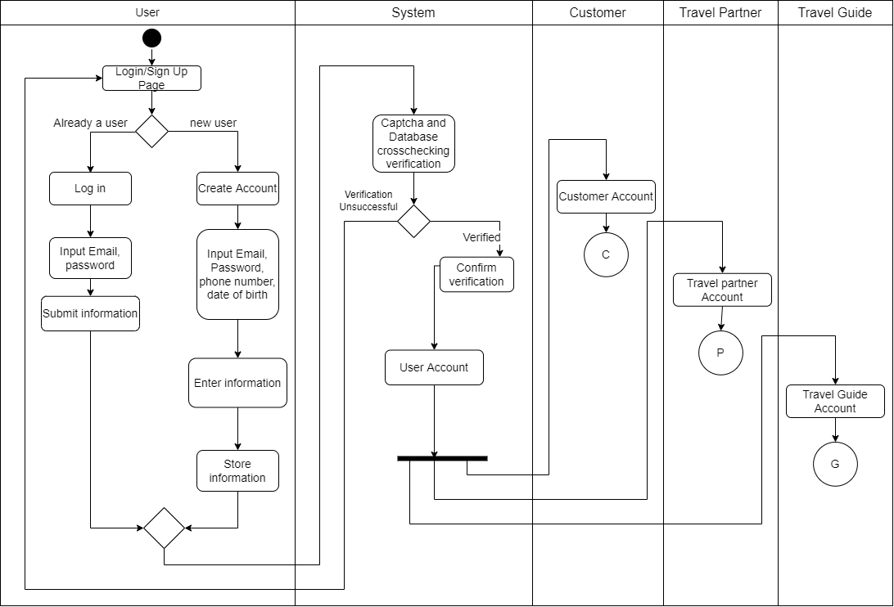

Short Description:

All of the users can both register and sign in into the system. To register,they need to provide their email address, password, date of birth and phone number. On the other hand, they can login using their registered email and password. While both login and register they need to pass the captcha verification test from the system. Also, their information will be stored in the database while they register.

Customer Activity Diagram:

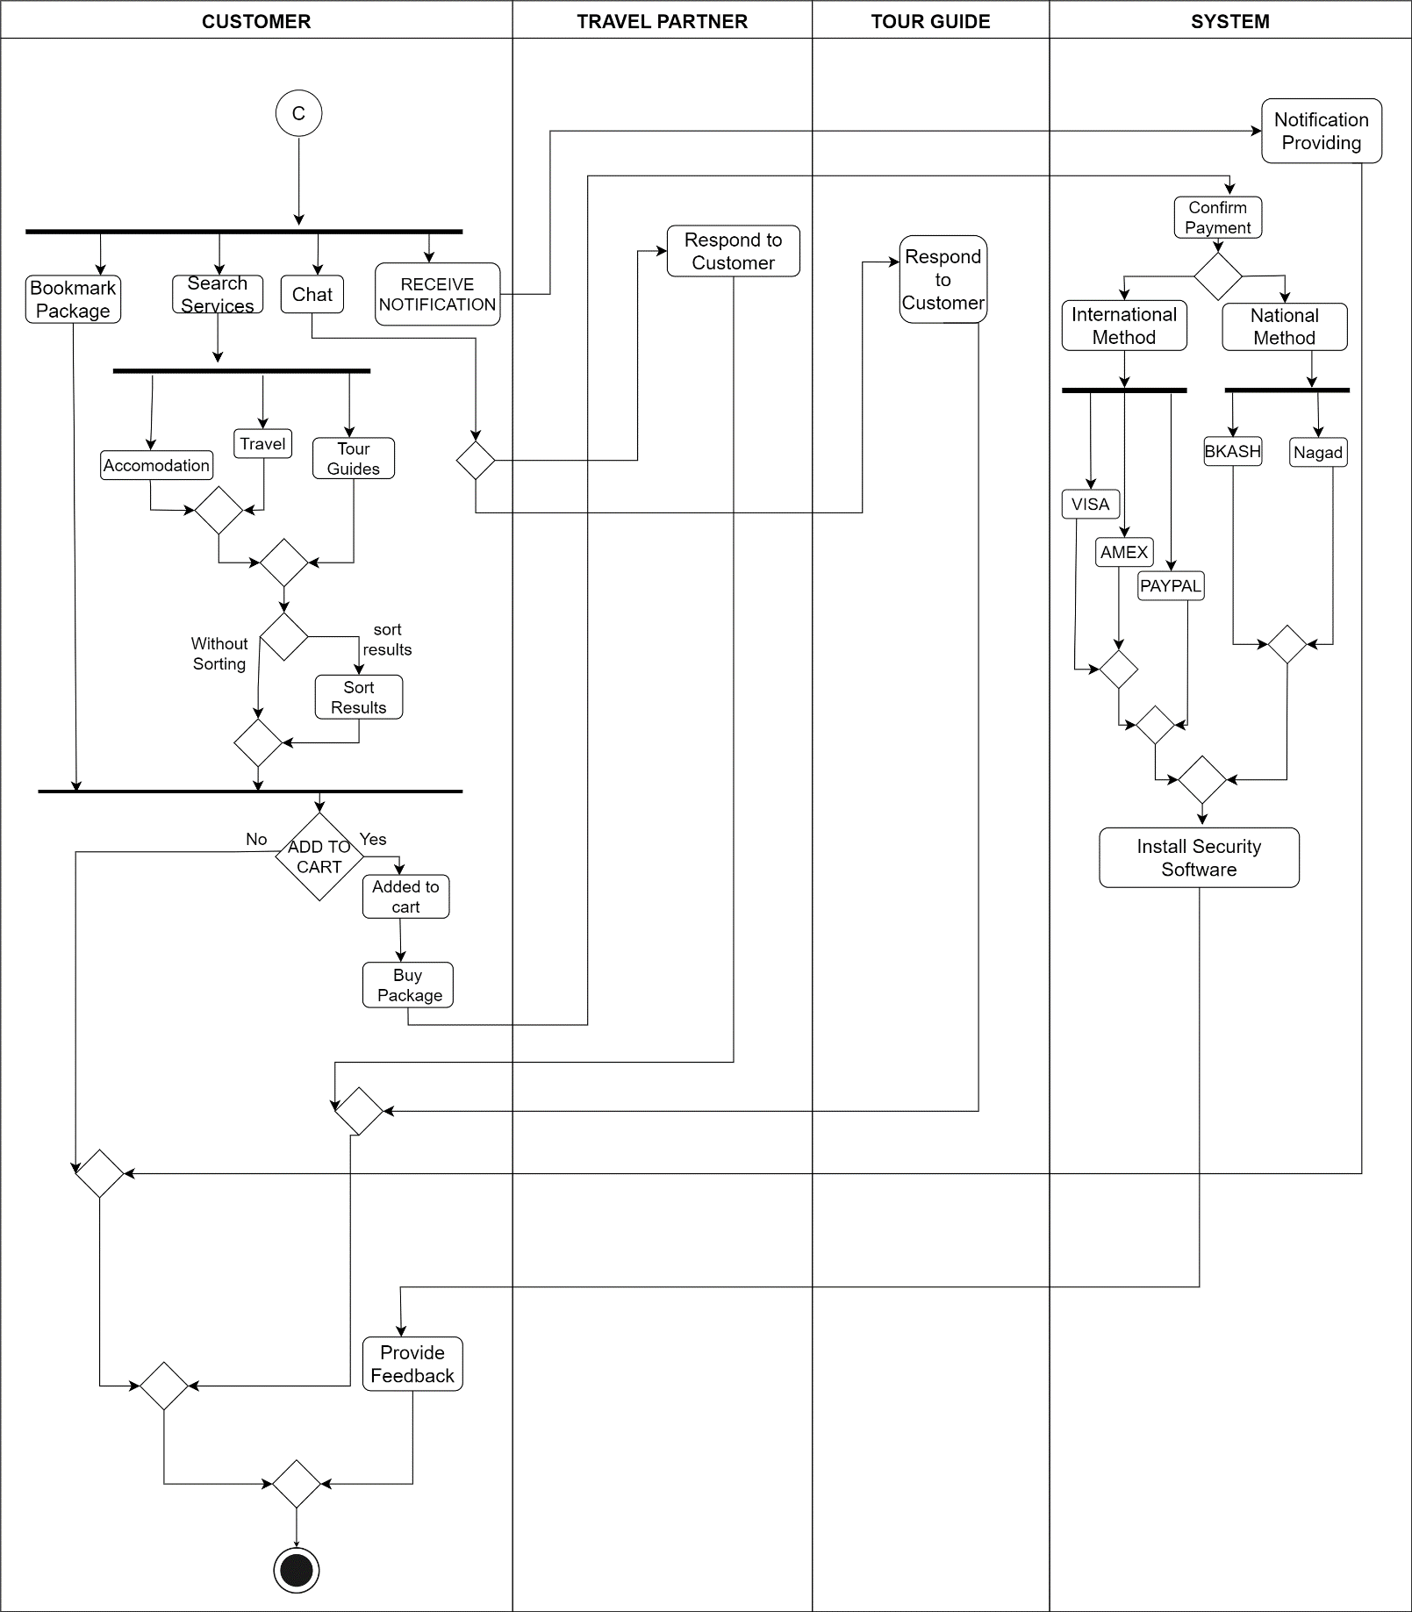

Short Description:

Here, customers can receive notifications,search services, chat and bookmark their favourite packages. They can sort packages depending on price,date, location and other criteria. They can also book packages and confirm their payment using various payment methods. Whenever they add a package, a security device will be added to their cart free of cost.

Activity Diagram for Travel Partners:

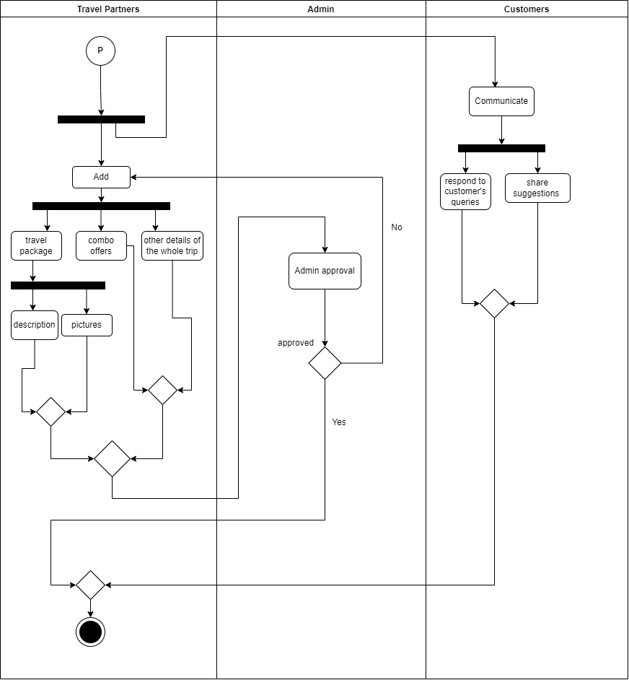

Short Description: The activity diagram "Travel Partner" represents features those travel agencies can access and update towards the system. Updating any feature to system require admin approval. Here, agencies can also directly chat with customers, provide suggestions and services.

Activity Diagram for Tour Guides:

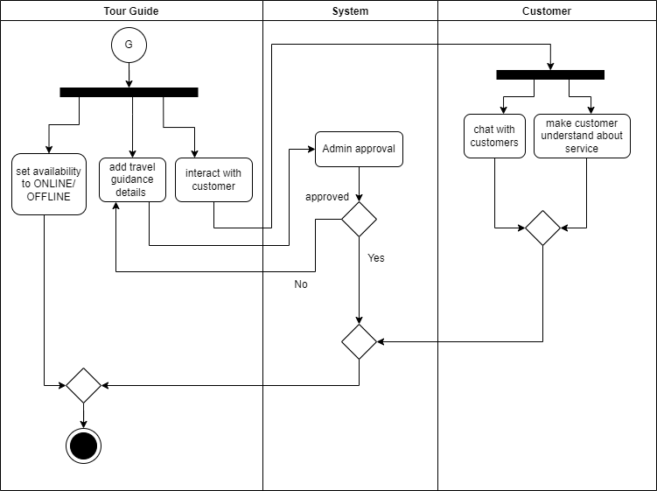

Short Description

The activity diagram "Tour guide" shows the guide facility to the system. Here, travel guides can add and update all guidance details to the system which require admin approval. Guides can also set their availability status. Besides, they can directly interact with customers and provide their services.